**Module 4:- Hardware**

**1. What is the first step in the troubleshooting process?**

**Answer:**

* **b) Identifying the problem**

The first step in troubleshooting is to identify the problem, which allows you to define the issue clearly before moving forward with finding a solution.

**2. Which of the following tools is commonly used to diagnose hardware issues by testing electrical connections?**

**Answer:**

* **c) Multimeter**

A multimeter is a tool commonly used to measure electrical properties such as voltage, current, and resistance, and can be used to diagnose hardware issues related to electrical connections.

**3. Which Windows utility can be used to view system logs, monitor performance, and diagnose hardware and software issues?**

**Answer:**

* **c) Event Viewer**

Event Viewer allows users to view system logs, monitor performance, and diagnose various hardware and software issues by displaying detailed logs of system events.

**4. True or False: Safe Mode is a diagnostic mode in Windows that loads only essential system services and drivers, allowing users to troubleshoot and fix problems with the operating system.**

**Answer:**

* **True**

Safe Mode is a diagnostic startup mode in Windows that loads only essential drivers and services, making it useful for troubleshooting and resolving issues that might prevent the system from booting normally.

**5. True or False: A system restore point is a snapshot of the computer's system files, registry, and configuration settings at a specific point in time, which can be used to revert the system to a previous state if problems occur.**

**Answer:**

* **True**

A system restore point is a snapshot of the system’s configuration at a specific time and can be used to revert to a previous working state in case of problems or issues with the system.

**6. True or False: Ping is a command-line utility used to test network connectivity by sending ICMP echo requests to a target device and waiting for ICMP echo replies.**

**Answer:**

* **True**

The ping command is used to test network connectivity by sending ICMP echo requests to a target device and waiting for an echo reply. It helps in diagnosing network connectivity issues.

**7. Describe the steps involved in troubleshooting a computer that fails to boot into the operating system.**

**Answer:**

1. **Check for Power Issues**: Ensure the computer is powered on and all cables are securely connected.
2. **Observe Startup Behavior**: Look for any error messages or abnormal behavior (like a black screen).
3. **Check Hardware Connections**: Inspect the internal components such as RAM, hard drive, and cables.
4. **Boot into BIOS/UEFI**: Verify the boot order and check if the hard drive is detected.
5. **Use Bootable Media**: Boot from a recovery USB or CD to attempt repair.
6. **Run Diagnostics**: Use hardware diagnostic tools to check for issues with RAM, hard drive, etc.
7. **Use Safe Mode**: Try booting in Safe Mode to isolate software or driver-related problems.
8. **Repair the OS**: If necessary, use system recovery tools or reinstall the OS.

**8. Demonstrate how to troubleshoot network connectivity issues on a Windows computer using the ipconfig command.**

**Answer:**

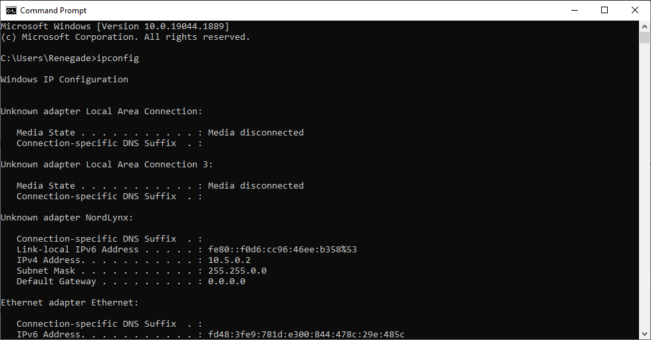

1. **Open Command Prompt**: Press Win + R, type cmd, and hit Enter.
2. **Run ipconfig**: Type ipconfig and press Enter to display the computer's IP address, subnet mask, and default gateway.
3. **Check for a Valid IP Address**: Verify that the IP address is correctly assigned (not 169.254.x.x).
4. **Release and Renew IP Address**: Type ipconfig /release to release the current IP, then ipconfig /renew to get a new one.
5. **Flush DNS**: Use ipconfig /flushdns to clear the DNS cache if there are issues with resolving domain names.
6. **Ping the Default Gateway**: Use ping <gateway_ip> to ensure the computer can reach the router.
7. **Ping External Website**: Use ping google.com to test if the computer can access the internet.

**9. Discuss the importance of effective communication skills in a helpdesk or technical support role.**

**Answer:** Effective communication is essential in a helpdesk or technical support role for several reasons:

1. **Clarity**: It helps in explaining complex technical solutions in a way that non-technical users can understand.
2. **Problem Understanding**: Clear communication ensures that both the technician and the customer are aligned on the problem.
3. **Building Rapport**: Good communication builds trust and rapport with users, which is essential for customer satisfaction.
4. **Managing Expectations**: Clear communication helps set realistic expectations about timeframes and the resolution process.
5. **Instruction and Support**: Technicians need to provide step-by-step guidance on troubleshooting or fixing issues, which requires clear and concise instructions.
6. **Professionalism**: Effective communication conveys professionalism, which improves the overall service experience.
7. **Problem Resolution**: It helps in quickly diagnosing the issue, as users can describe their problems more effectively.